**Testing Assignment**

**A.Features that works well in internshala Website**

**Feature 1- Search functionality** 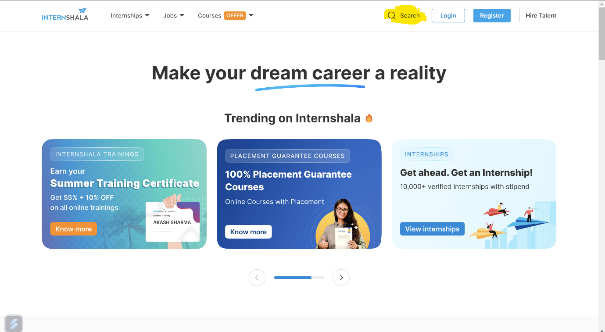

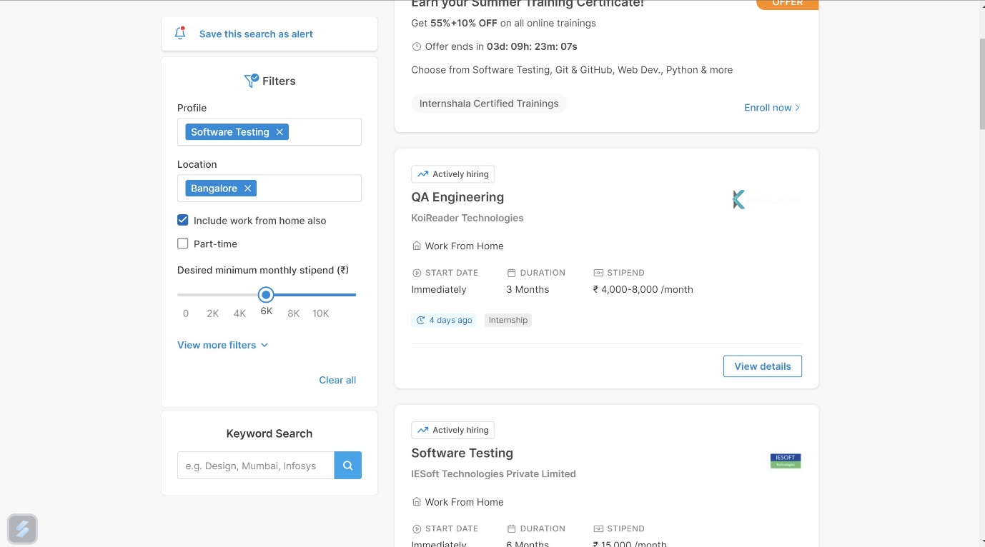

**Feature 2- Login functionality**

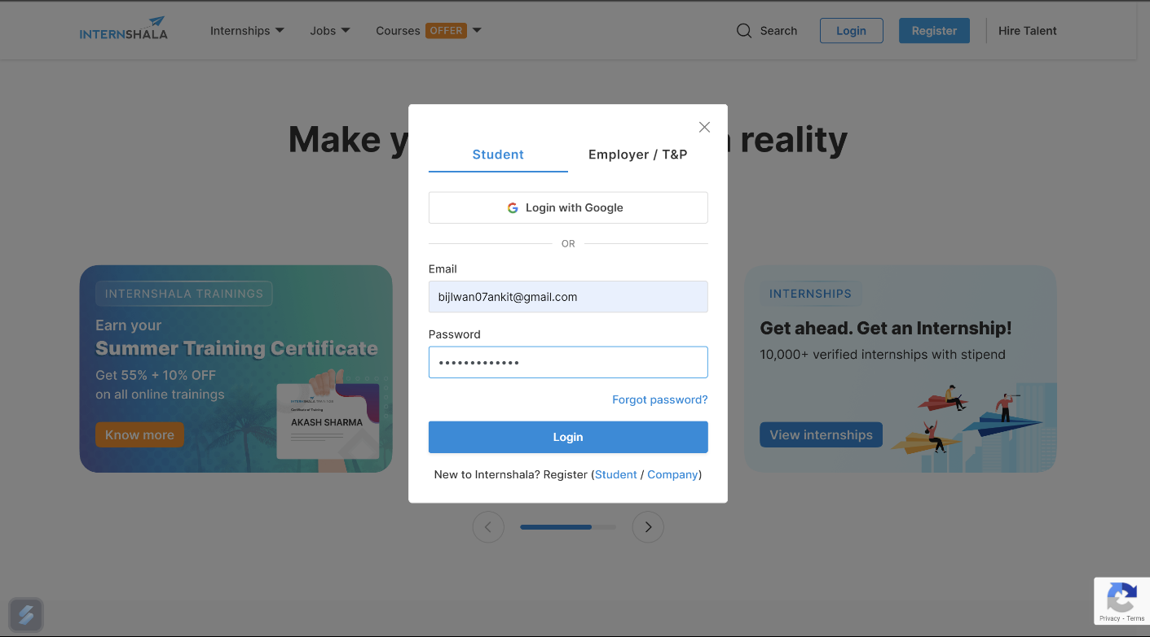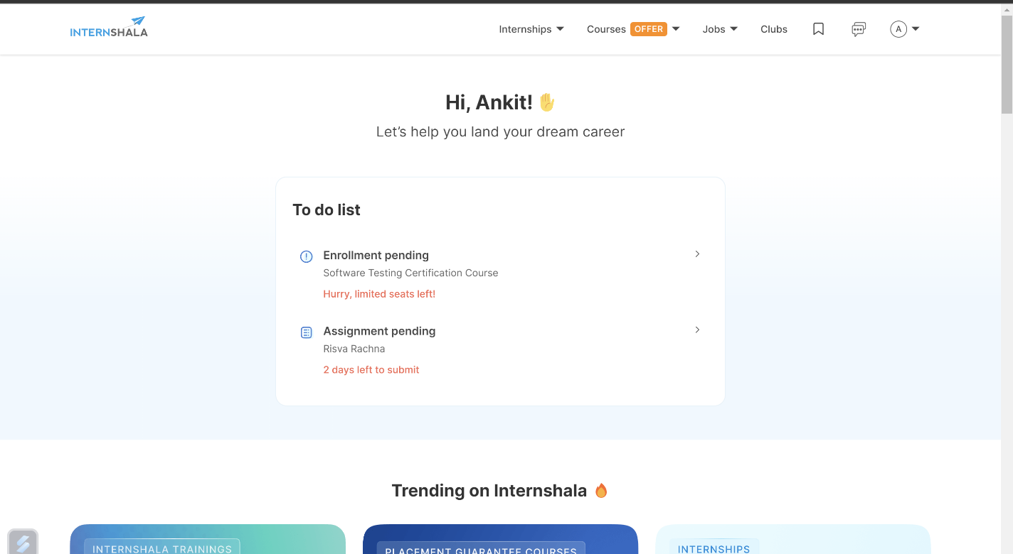

**Feature 3- internship by Category functionality**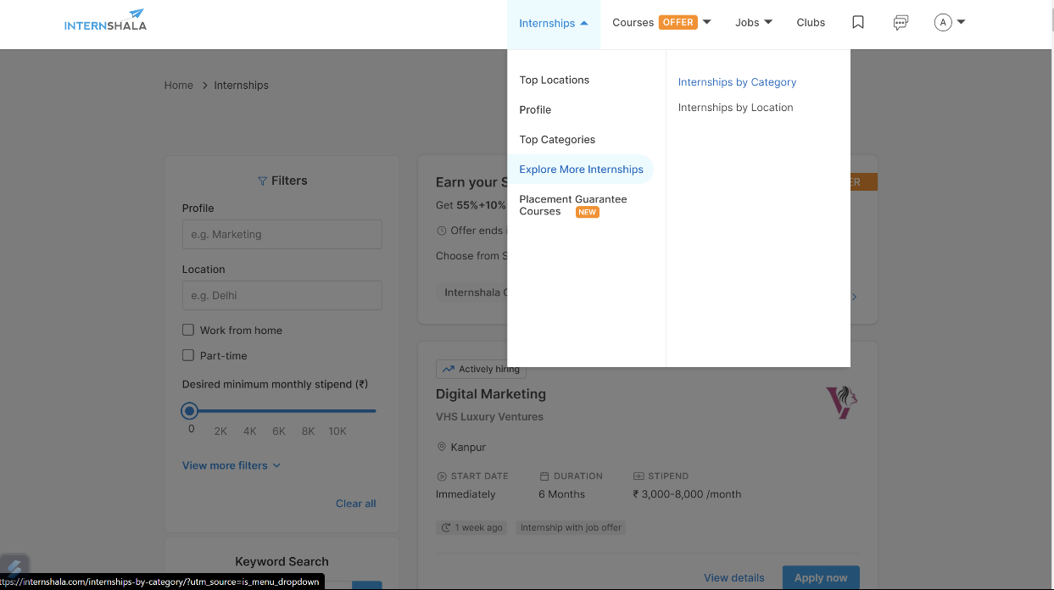 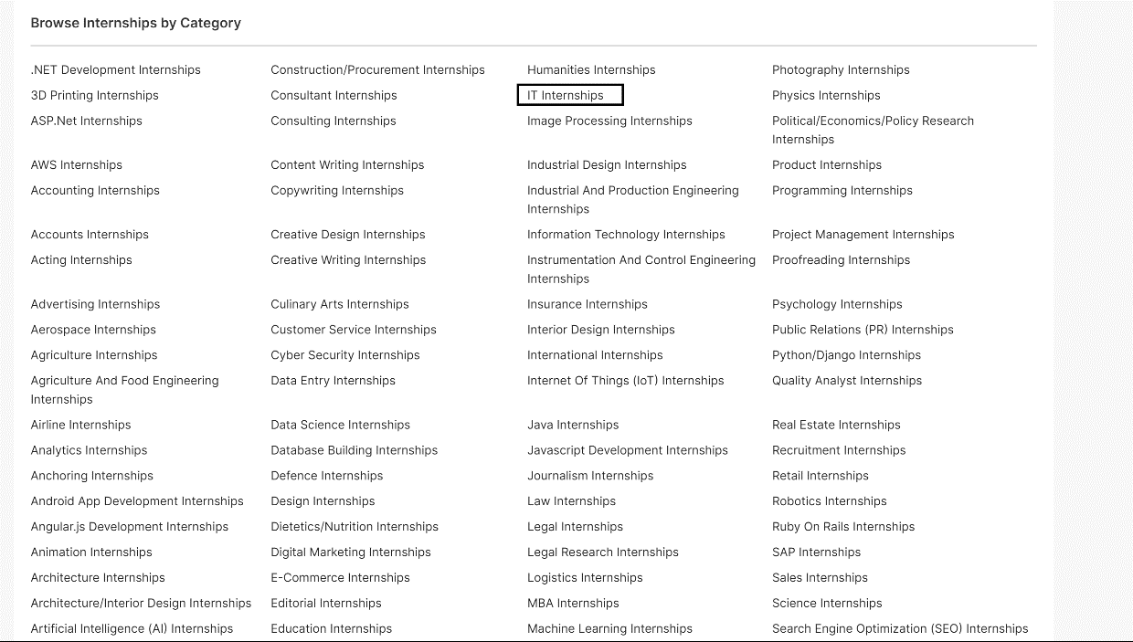

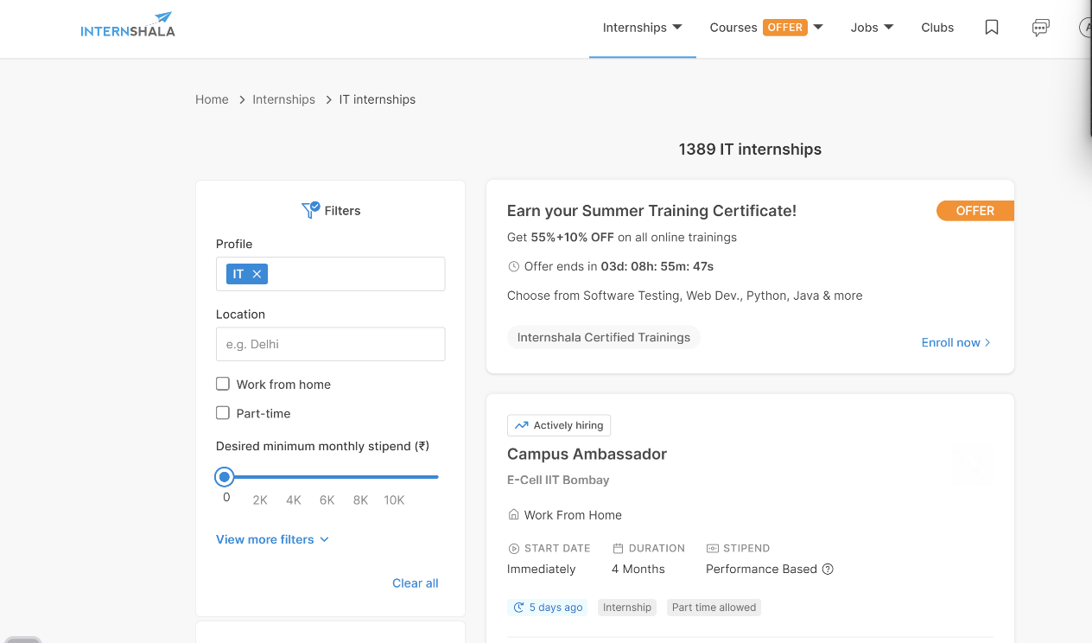

**Feature 4- internship by location functionality**

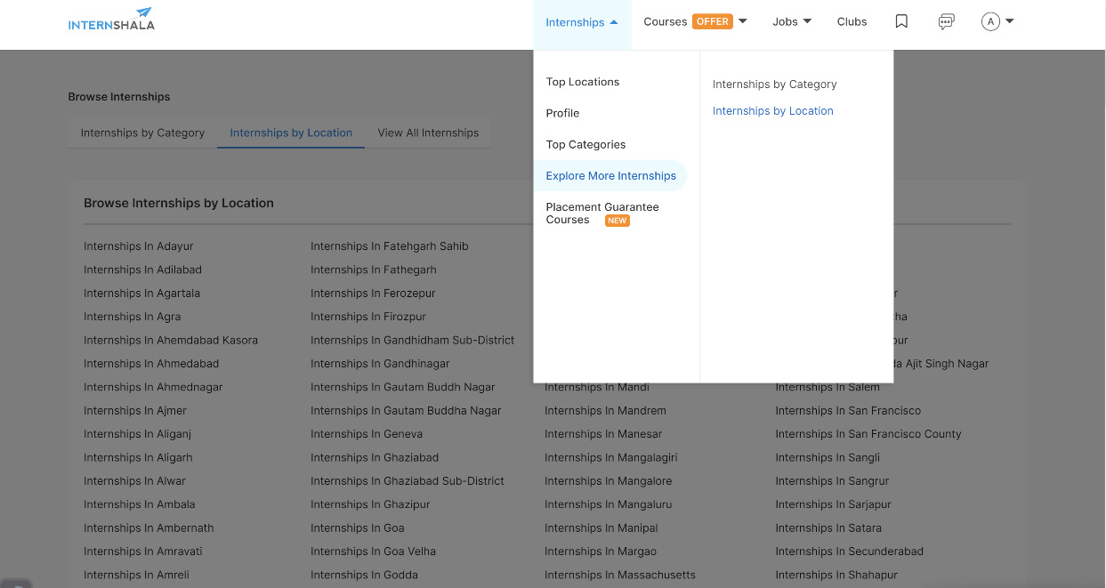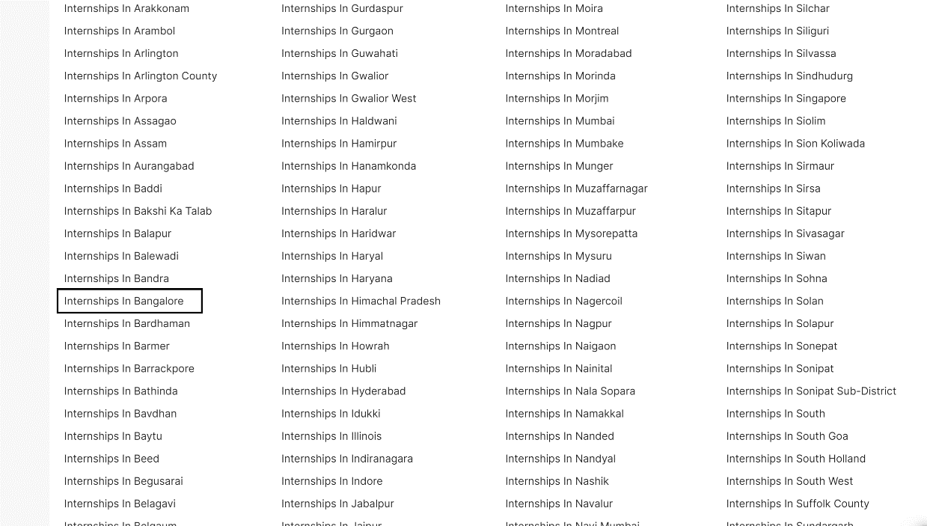

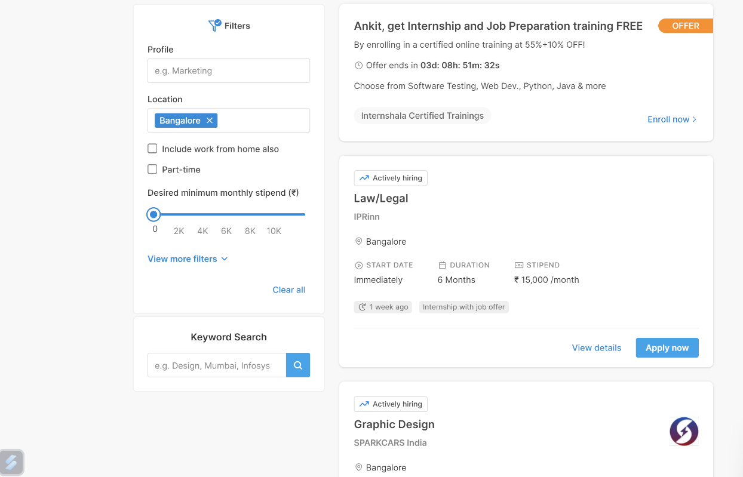

**5.internship for women filter functionality**

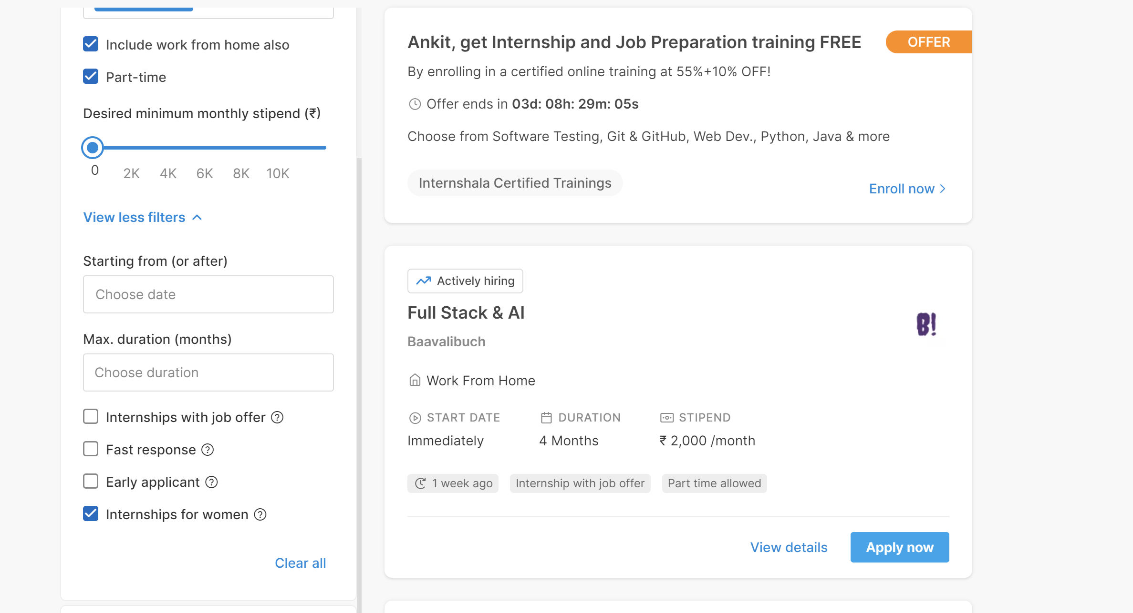

**B. scenario does not work well**

**1. After Logged in in my home page I did not find search button**

**Priority-(P1)**

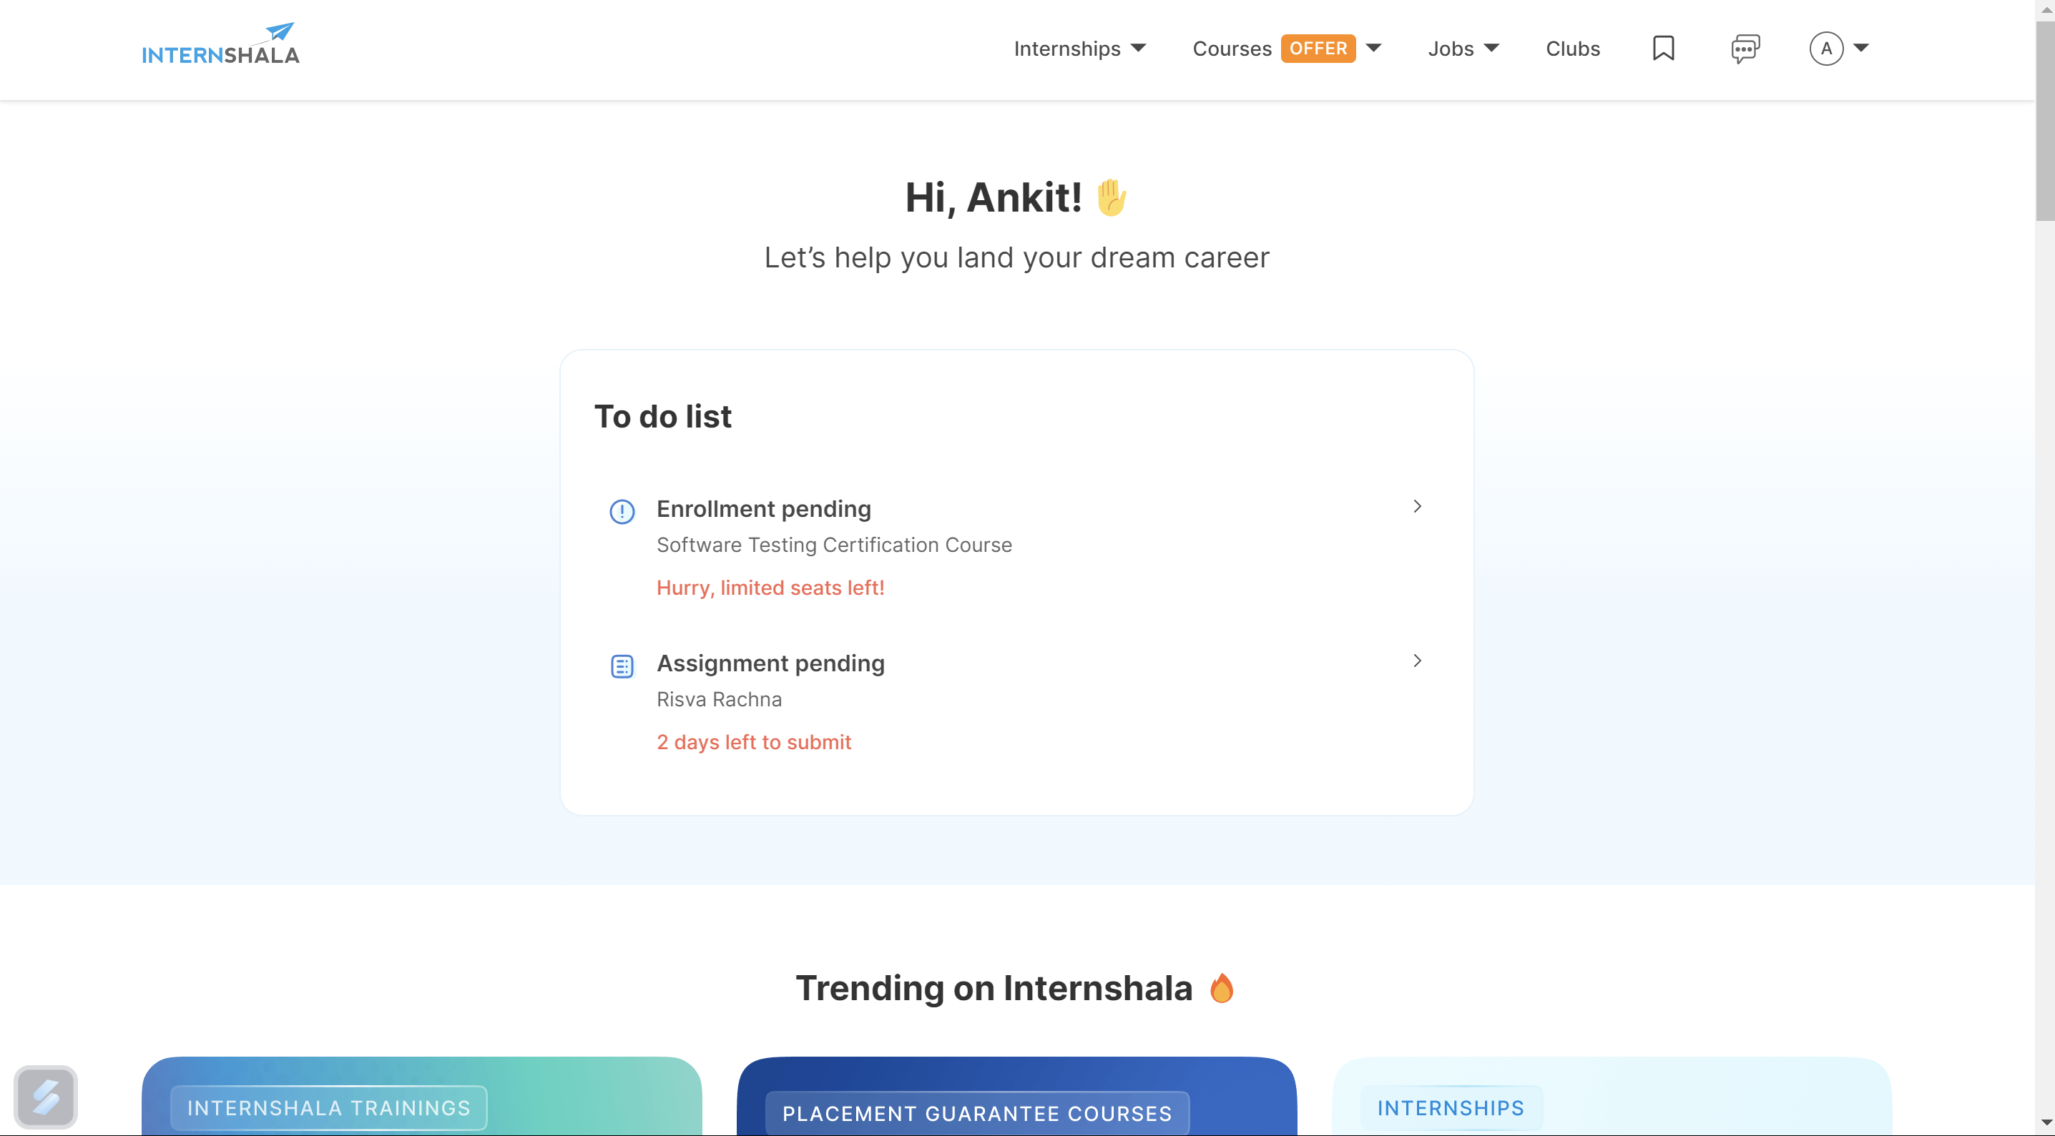

**c. What can we do better**

**There Must be a search button in Every page for easy navigation or access.**

**2.In Most important terms and condition point no 11 instead of “Whatsapp” it should be “WhatsApp”.**

**Priority-(P3)**

